|  |  |
| --- | --- |
|  | Hang up backpack |
|  | Empty lunch bag |
|  | Eat a snack |
|  | Homework |
|  | Practice |
|  | Read 20 minutes |
|  | Chores |

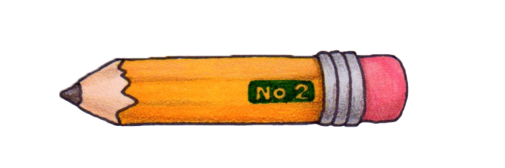After School: